Project Proposal

BikeTracks App Development



**Team 8:** ERROR [FileNotFound]

## 

**Table of Contents**

Tentative role(s)

Executive Summary

Background and Rationale

Project Approach

Project Plan

Table of Authorship

References

## Tentative role(s)

| **Name** | **Role(s)** |
| --- | --- |
| Yash Sood | Software Developer |
| Yuyuan Wu | Product Manager |
| Aaron Fan | Software Tester |
| Dustin Su? | Software Developer |
| Sura Liu | Software Developer |
| DUSTIN Li | Project designer |
| Youlun Li | Project Analyst |

## ···· ·1·

## 

## Executive Summary

At present, more and more experts are appealing to people who choose environmentally friendly ways to commute. A low carbon lifestyle is helpful to protect the earth's environment from saving good resources for the next generation. Commuting by bike or e-scooter or by foot is good for the environment and beneficial for people's physical health since nowadays most people lack exercise.

However, few applications on the internet are designed to track users' locations and speed, but they are only designed for fitness and fitness stats purposes. No mobile application is designed for bike users to track their daily transportation route and suggest commuting. The purpose of our team to develop this BikeTrack Application is to track users' commuting routes, distinguish different types of vehicles that users used; the speed and acceleration of the vehicle when the user is traveling, and analyze the most frequent routes to give the user commuting suggestions. This project is ideal to ask for access to the user's smartphone sensor first, then collect data and store it in the local database, finally analyzing their information with the support of machine learning related knowledge.

Our team would like to assist users to notice the importance of environmental protection and increase their willingness to transfer to a low carbon lifestyle. As it's a more healthy and environmentally friendly way to travel for work, we also helped users track and record their daily traveling route, which allows users to compare their changes by themselves.

To accomplish our desired outcome, we aim to design a comparison between bikes/scooters and fuel combustion vehicles. As well as producing a little diagram to show the frequency users traveled using different vehicle types by GPS, the acceleration will be automatically calculated at the application's back-end then directly displayed on the screen.

As a team made up of seven people, we are delicate at producing the best app for the clients as each of our team members are from different backgrounds and familiar with other areas like data analysis, algorithm, database management, machine learning, application development, and lastly user computer interaction. Hence, we can allocate different tasks based on our respective areas and confidently provide the best outcome.

## Background and Rationale

As the population increases in New Zealand, more and more people rely on cars for travelling to work; there are more than 60% approx New Zealanders aged 15 years and over in 2018 who choose to drive to their work (see figure 1 below), but there is only 2% of people who select bicycles for daily travelling. As the environmental problem becomes a serious issue right now, we decided to design an application that encourages users to choose a more environmentally friendly way for their daily commute.

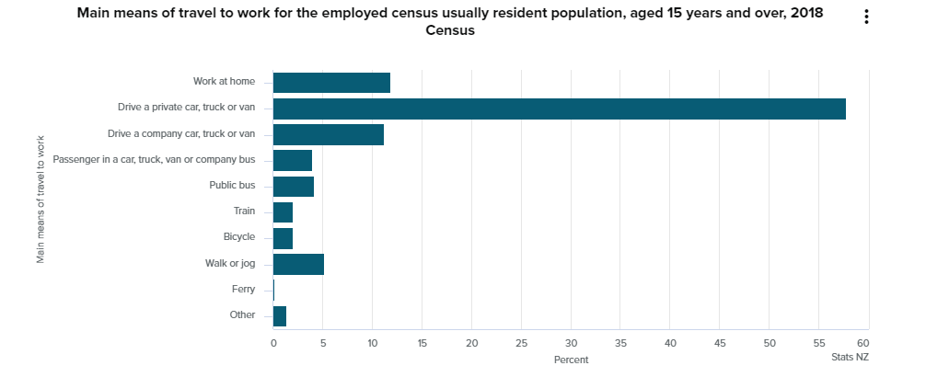

(Figure 1)

According to the statistical data from Stats NZ (Figure2), the net carbon dioxide emissions have increased from -3.161 million tones to 11.512 million tones, and the net greenhouse gas emissions have increased from 63.591 million tones to 78.862 million tones from 1990 to 2018 (See from figure2). In 2018, 47% of the total carbon dioxide emissions were from transport, and the greenhouse gas emissions are mainly caused by carbon dioxide (44.5%). Based on the analysis of the data, we can state that the high demand for transportation is the main reason that causes the increased emissions of greenhouse gases and carbon dioxide.

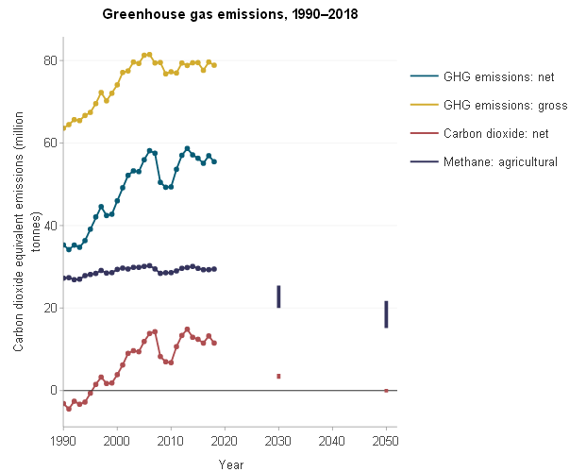

(Figure 2)

Car emissions are the main section of transportation emissions. The car emissions are pushing dramatically because of burning petrol. This exacerbates the air pollution. Plus, car emissions contain a wide range of gases and solid matter which will cause global warming, acid rain, and damage to the environment and human health. The engine noise emmit by the car and the fuel spills will also harm the environment. Conversely, riding bikes as daily commuting transportation is a way to reduce the noxious gas emission to protect the environment.

By comparison with a similar location tracking application: Zenly. Zenly is a location sharing application but it also has multiple functions, for example, tracks users’ routes, records the location, calculates the speed and acceleration then saves the records under users’ accounts with the use of a solid algorithm. The way they are able to achieve those functions is to access the GPS data from individual phones to estimate the movement and base on the time it travels through to figure out the speed and acceleration. Our BikeTrack app does not need to accomplish the location function. However, the principle of tracking travel routes and calculating the speed and acceleration of the bike should be quite similar.

Our Project aimed to record users' speed, location, and total commuting time, which helps the users understand how much time they spent on daily commute using bicycles in both Android and IOS environments. Our application's ultimate goal is to use data analyzing methods such as machine learning to manipulate data to distinguish vehicle type users using as their daily transportation. However, the idea is only used for our implementation, and it is not a guaranteed function.

Specific Aims:

* Design different API interfaces based on the different operating system
* Users can start and stop the tracking functions
* Users can choose the type of the vehicle when the tracking
* Collecting data from mobile phone sensor every 30 seconds
* Uploading the data collected by the sensors to the local database/file
* Our application can run under different versions of the system and can run on the smartphone for the last 3-4 years.

Further Extension:

* Connecting the database to the backend algorithms to analyze the data
* Identify the vehicle type users using based on machine learning and smartphone sensor data.
* Analyze users vehicle usage every week and output a diagram to inform users how much time they have spent on transportation
* Analyze users’ most frequent departure locations and destinations to obtain the commuting routes.
* Create fields to allow users to fill in their home addresses and work addresses in the app

## Project Approach

First of all, we need to choose a proper software development kit (SDK) to build the UI framework of the mobile application. Flutter should be the most suitable SDK as only one programming language and one codebase are needed to generate the applications for two different mobile phone systems, both Android and IOS. ( Before, developers always used the Java framework, and they had a bridge, usually, a web view, to render all of the widgets or user interface of the platform ios or android. Then there is also a way to tap into the native SDK for each practical type. However, if we use flutter and dart, the bridge is gone, and we do not need that bridge. We go straight to native SDK libraries, and we have from the same code base that we have the application run android and ios). Another is to fetch routes and speed data from sensors using Google Map interfaces to add maps in the Android and IOS apps.

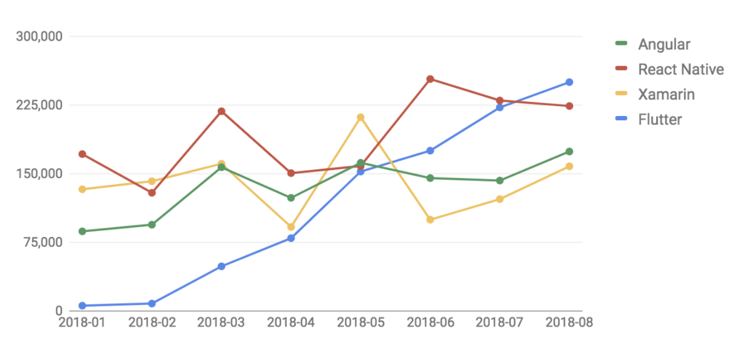

(Figure 4)

People having more magnificent enthusiasm on Flutter on StackOverflow is shown by this chart.

The flutter is an open-source SDK to quickly generate apps that can run under Android and IOS. Dart is used as the programming language similar to Java on syntax, as we learned before in university. Compared with Java and Kotlin, Dart is simple but powerful and complete. Although any text editor can be used to write and build the app, Android Studio would be the most suitable editor since it supports the Flutter plugin. There is hot reloading in the flutter. Just change the code in the code editor, and UI refreshes on the Android emu for iOS sim automatically after saving the changes.

Secondly**,** we need to do some machine learning that can help us evaluate data collection and simulated scenarios more accurately. If more than 25 records share the exact start locations and destinations within 30 tracks, then those records should be considered commuting routes; the departure location and the destination location should be recorded as the frequent address. It is necessary to conduct field tests and collect information that can help us get a deeper understanding of the goal of the application; for example, we can organize our team members to ride a bike, drive a car, and ride a scooter on the same route separately and record all the speed, time and route data, upload those data and do the comparison between them and this will allow us to find the key data that distinguishes e-scooters, bikes, and cars. A Decision Tree is a suitable machine learning method to do that. We may also need to build a database with SQLite, collecting users' data from Google maps and storing it.

Thirdly, we need to do a little preparation for application design and UX research. We can research why customers choose to use the most popular existing tracking apps, for example, Zenly and Google maps. We can provide questionnaires for potential users(people who often use tracing apps) and ask them to write down their experience using the most popular tracing apps on the market. Based on those feedbacks, we can clearly understand what the advantages of those apps are. Our application design can refer to the data obtained by our research. This step is not the critical point, but it is also necessary to do that.

## Project Plan

Project objectives:

The project objective is to launch a BikeTrack application that can track location data and calculate acceleration to distinguish commuting tracks performed by bike or e-scooter with tracks performed by car or motorbike within $500 budgets 28/10/2021.

The focus of this project will be mainly on creating a program/algorithm that would help differentiate, through the use of sensor data, what vehicle the user is travelling in. The Minimum Viable Product (MVP) that our team will develop will contain at least two sources of sensor data input to help determine such. As the clients view on the finality of the app is yet to be determined, the team will focus on creating the most efficient algorithm, which would use little computing power, as we are advised to keep the app local with no server communication. The first objective would be to research variables of sensor data and how accurate they can be.

Priority matrix:

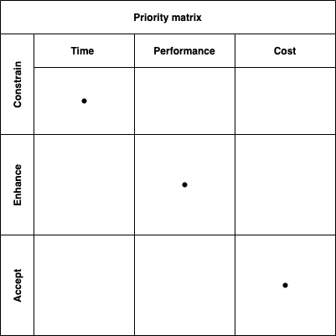

From this project, it is considered that the time attribute should belong to a constraint because the project time and deadline are fixed, it should belong to Enhance for Performance because the BikeTrack application is a service industry that will serve users. So we must develop an application for performance that will improve users’ satisfaction. For the cost, we don’t have specifical budget limitations, and reasonable costs can be accepted.

Deliverables:

* A list of specifications
* Functional requirement document
* Software coding
* Test prototype
* Well-designed database
* Accurate algorithm
* Final test and approval

Milestones:

* Project proposal approved --- 10/08/2021
* Machine learning & programming language learning complete--- 20/08/2021
* Low fidelity application approved --- 25/08/2021
* High fidelity testing passed --- 2/11/2021
* Application launched --- 16/11/2021

Technical requirements:

* Application must launch on both Android and IOS system
* The allowance of the highest peak visits in the same time period should be 1000 visits
* Should at least support last 3 years devices version

Gantt Chart:

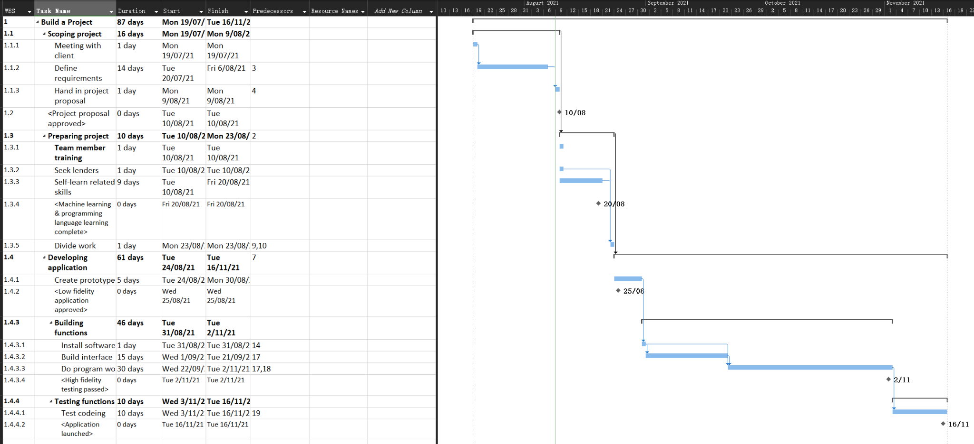

## Table of Authorship

| Title Page | Aaron Fan / Yash Sood |
| --- | --- |
| Executive Summary | Aaron Fan /Shan Li /Sura Liu |
| Background and Rationale | Sura Liu /Aaron Fan/ Shan Li/Youlun Li/Zixuan Su |
| Specific Aims | Zixuan Su /Aaron Fan /Shan Li/Yuyuan Wu |
| Project Approach | Zixuan Su /Youlun Li /Yuyuan Wu |
| Project Plan | Youlun Li / Sura Liu / Yash Sood |
| Final Editing/Clean up/Design | Yash Sood |

## References

Figure 1: Kay Seatter-Dunbar (23 October 2019) from StatsNZ:

<https://www.stats.govt.nz/news/car-streets-ahead-for-travel-to-work-and-education>

[HANNAH WEINBERGER](https://www.bicycling.com/author/214249/hannah-weinberger/) (22 July 2021) from

<https://www.bicycling.com/bikes-gear/g20979462/the-best-phone-apps-for-cyclists/>

Figure 3: (ViaStrada 2021)

<https://viastrada.nz/e-bike-sales>

Figure 4: Marco Bellinaso (24 November 2018)

<https://medium.com/asos-techblog/flutter-vs-react-native-for-ios-android-app-development-c41b4e038db9>

20 reasons to cycle to work. (2021). BikeWeek. Retrieved from

<https://www.cyclinguk.org/article/20-reasons-cycle-work>

The benefit of low-carbon lifestyles. (2011). Health and well-being. Retrieved from

<http://www.theclimatebonus.org/lifestyle.php>

Effects of Car Pollutants on the Environment. 2018. Sciencing. Retrieved from

<https://sciencing.com/effects-car-pollutants-environment-23581.html>

New Zealand’s greenhouse gas emission. 2020. StatsNZ. Retrieved from

<https://www.stats.govt.nz/indicators/new-zealands-greenhouse-gas-emissions>

Traffic Data, Route Planning, and ETA: How Google maps predict travel time. 2020. Verizon Connect. Retrieved from

<https://www.verizonconnect.com/resources/article/google-maps-travel-time/>